Project Development Phase
Model Performance Test

Date | JUNE 2026
Team ID
Project Name | Plugging-into-the-Future-An-Exploration-of-Electricity-Consumption-Patterns
Maximum Marks

Model Performance Testing:
Project team shall fill the following information in model performance testing template.
S.No. | Parameter | Screenshot / Values
1. | Data Rendered | 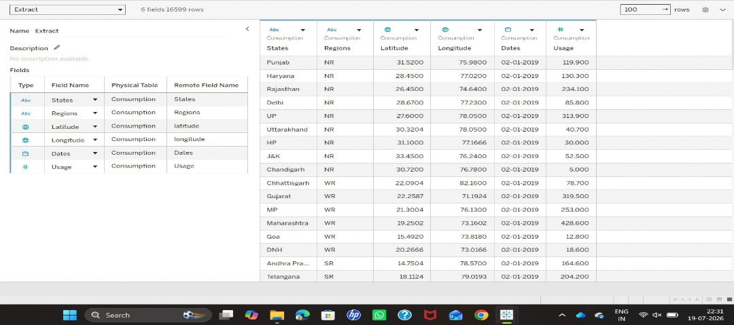  Successfully imported the Electricity Consumption dataset with fields including Electricity Consumption, Country, Region, Year, and more. Data is correctly displayed in Tableau and linked to visualizations.
2. | Data Preprocessing | Removed missing/null values, ensured data types (dates, strings, boolean) were correctly set, and added calculated fields such as year extraction from Date_inscribed. Filtered out redundant columns. Number of rows after cleaning data:16588
3. | Utilization of Filters | Implemented filters on Country, Region, and Year. Filters are interactive and applied to all visualizations for dynamic exploration.

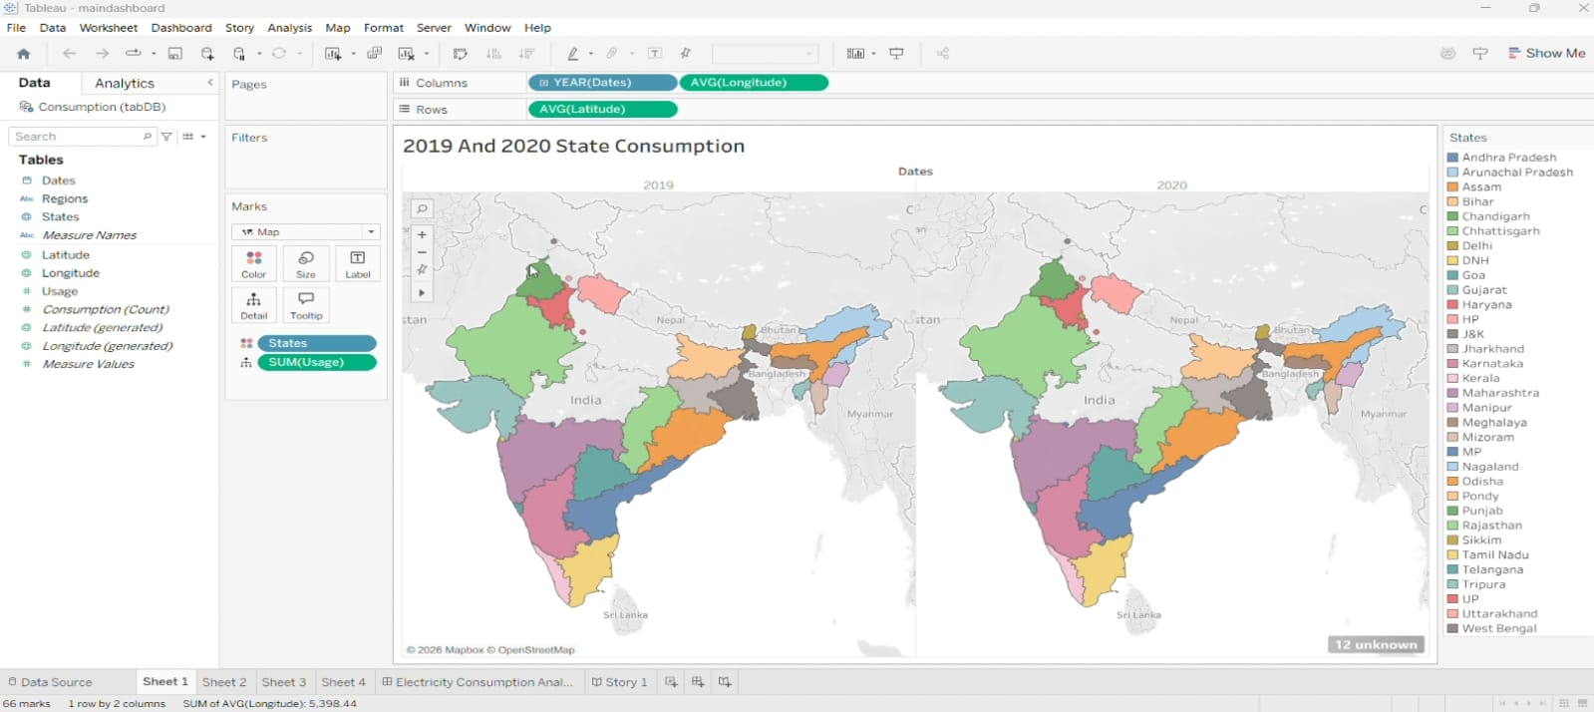

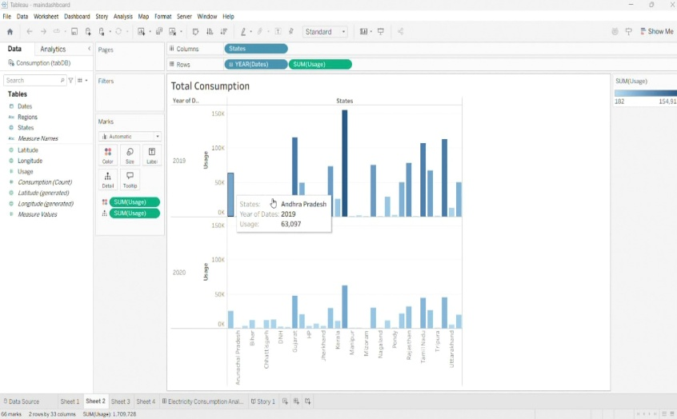
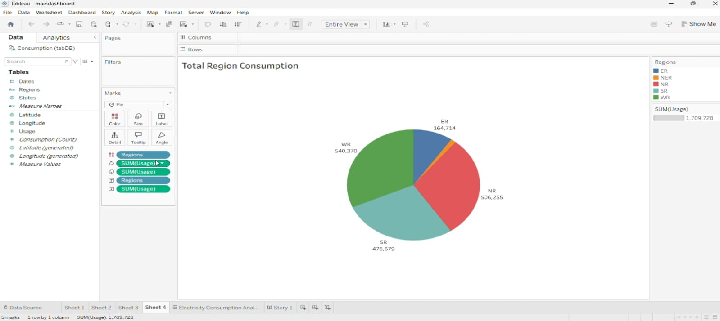

4. | Calculation fields Used | - Year Extracted from Electricity Consumption Date  - Total Electricity Consumption by Country  - High Consumption Flag for Pie Chart (IF [Electricity Consumption] >= Threshold THEN 'High Consumption' ELSE 'Normal Consumption')  - Region-wise Electricity Consumption Rate: SUM([Electricity Consumption]) / COUNT([Country])  - Consumption Decade: INT(YEAR([Date]) / 10) * 10  - Country-wise Electricity Consumption Percentage: (SUM([Electricity Consumption]) / TOTAL(SUM([Electricity Consumption]))) * 100
5. | Dashboard design | No of Visualizations / Graphs – 8  No of Dashboards designs- 1

 |  | 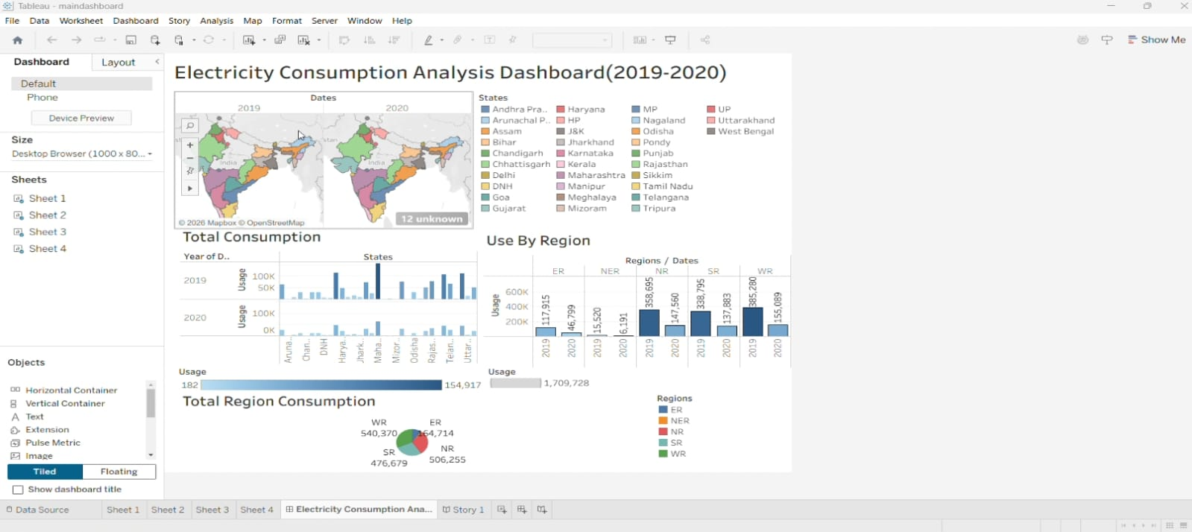
6 | Story Design | No of Visualizations / Graphs -8  No of Story Design- 1
